**1 . Create Repository**

Initialize a new project repository to store and track code changes.

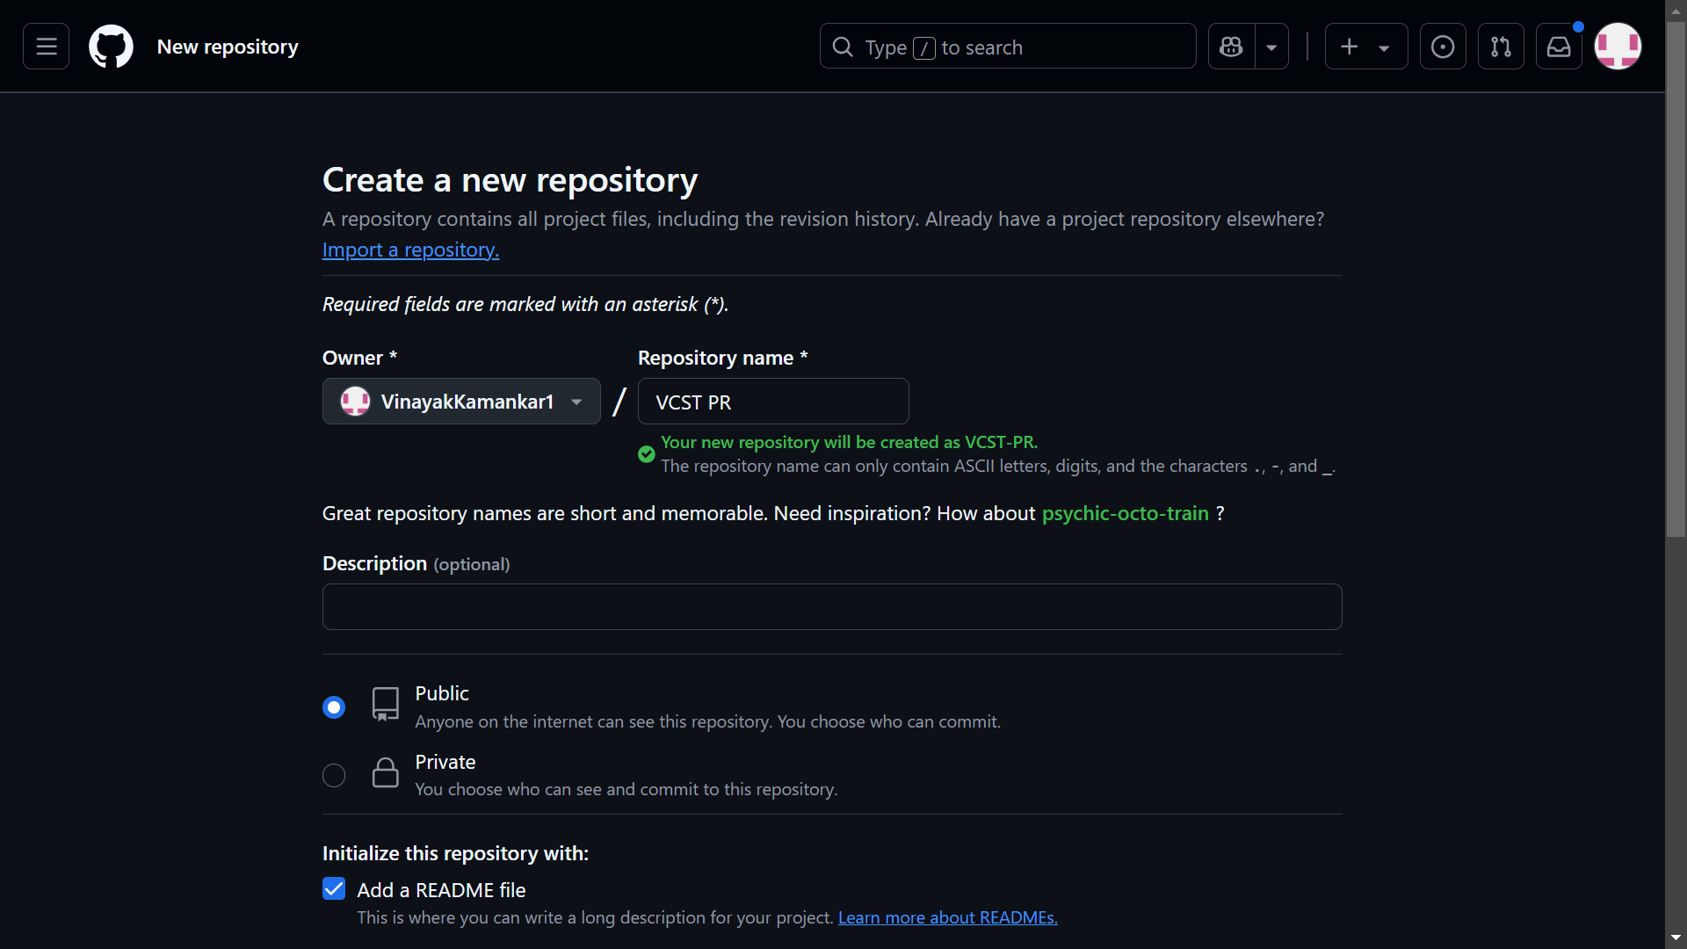

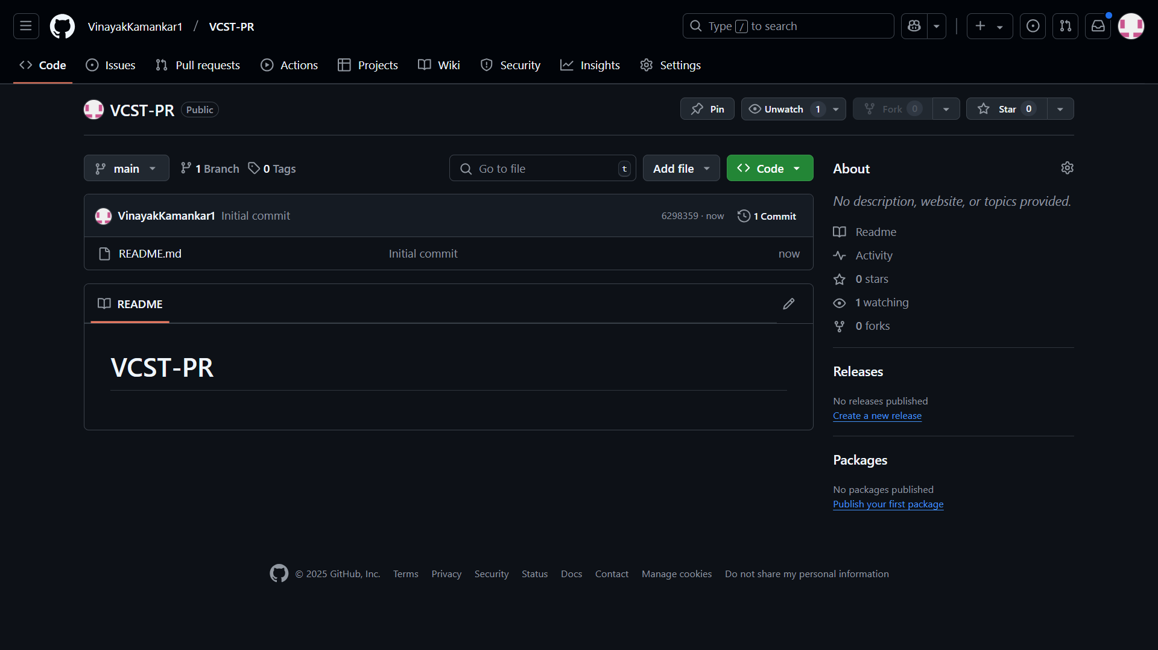

**2. Invite Collaboration**

Send invitations to team members to join and contribute to the repository.

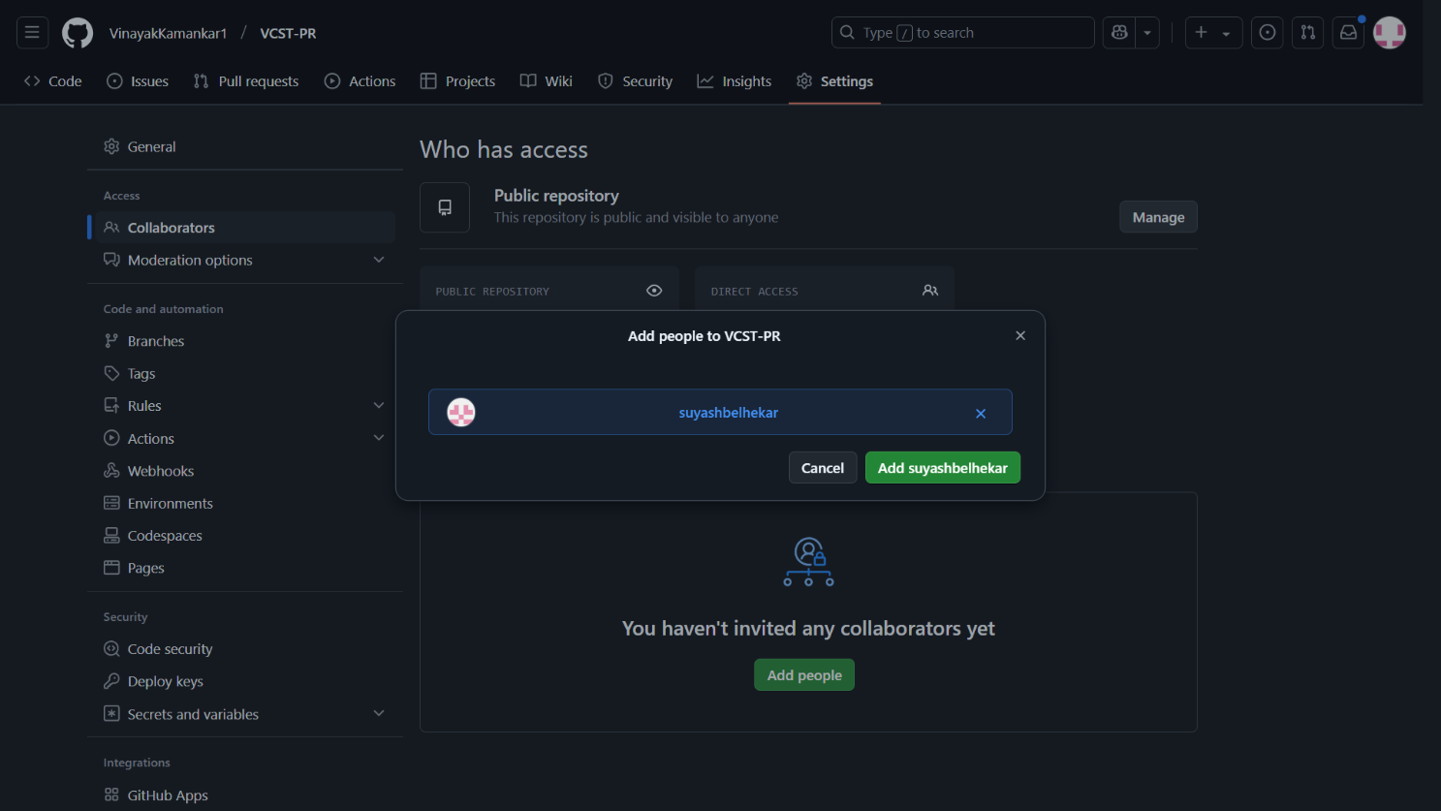

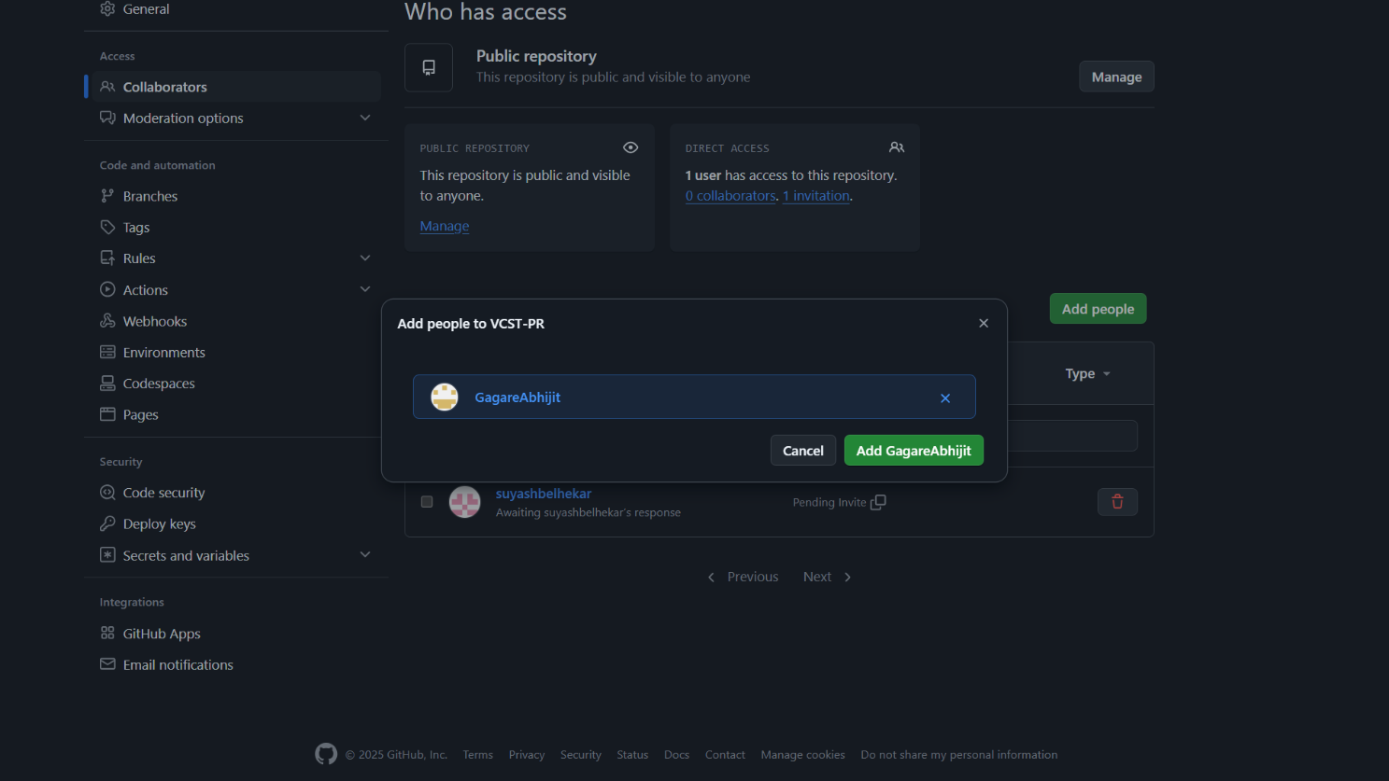

**4. Collaboration Pending**

The invitation is sent but has not yet been accepted by the user.

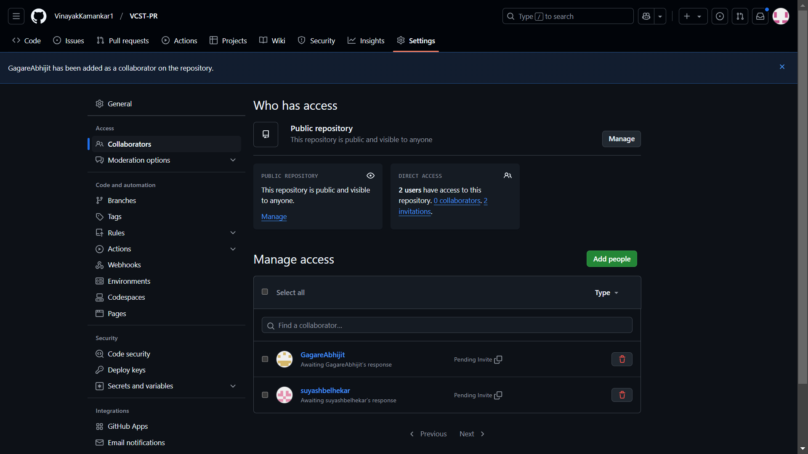

**3. Request Accept**

The invited user accepts the request and gains access to the repository.

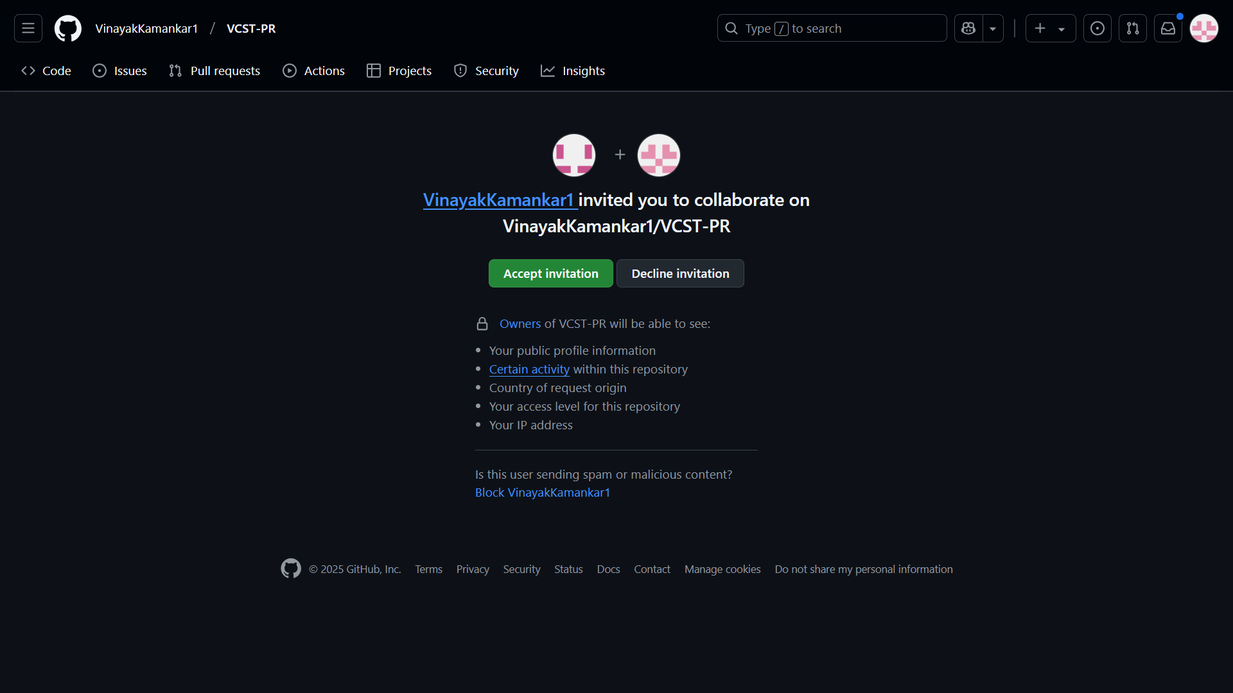

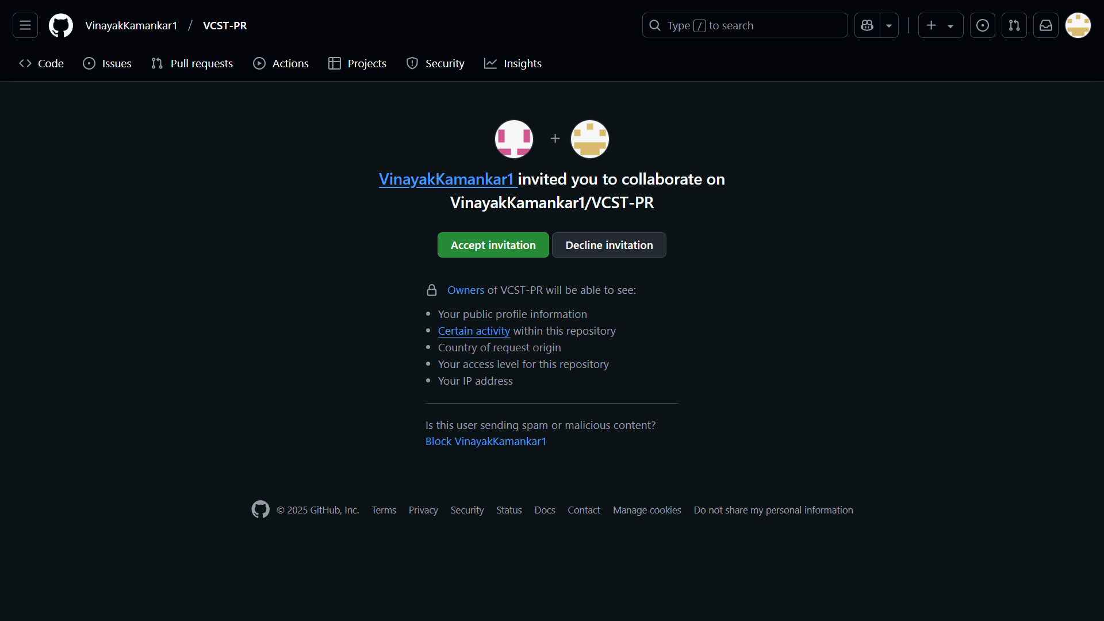

**5. Collaborated Succesfully**

The user has joined and can now contribute to the repository.

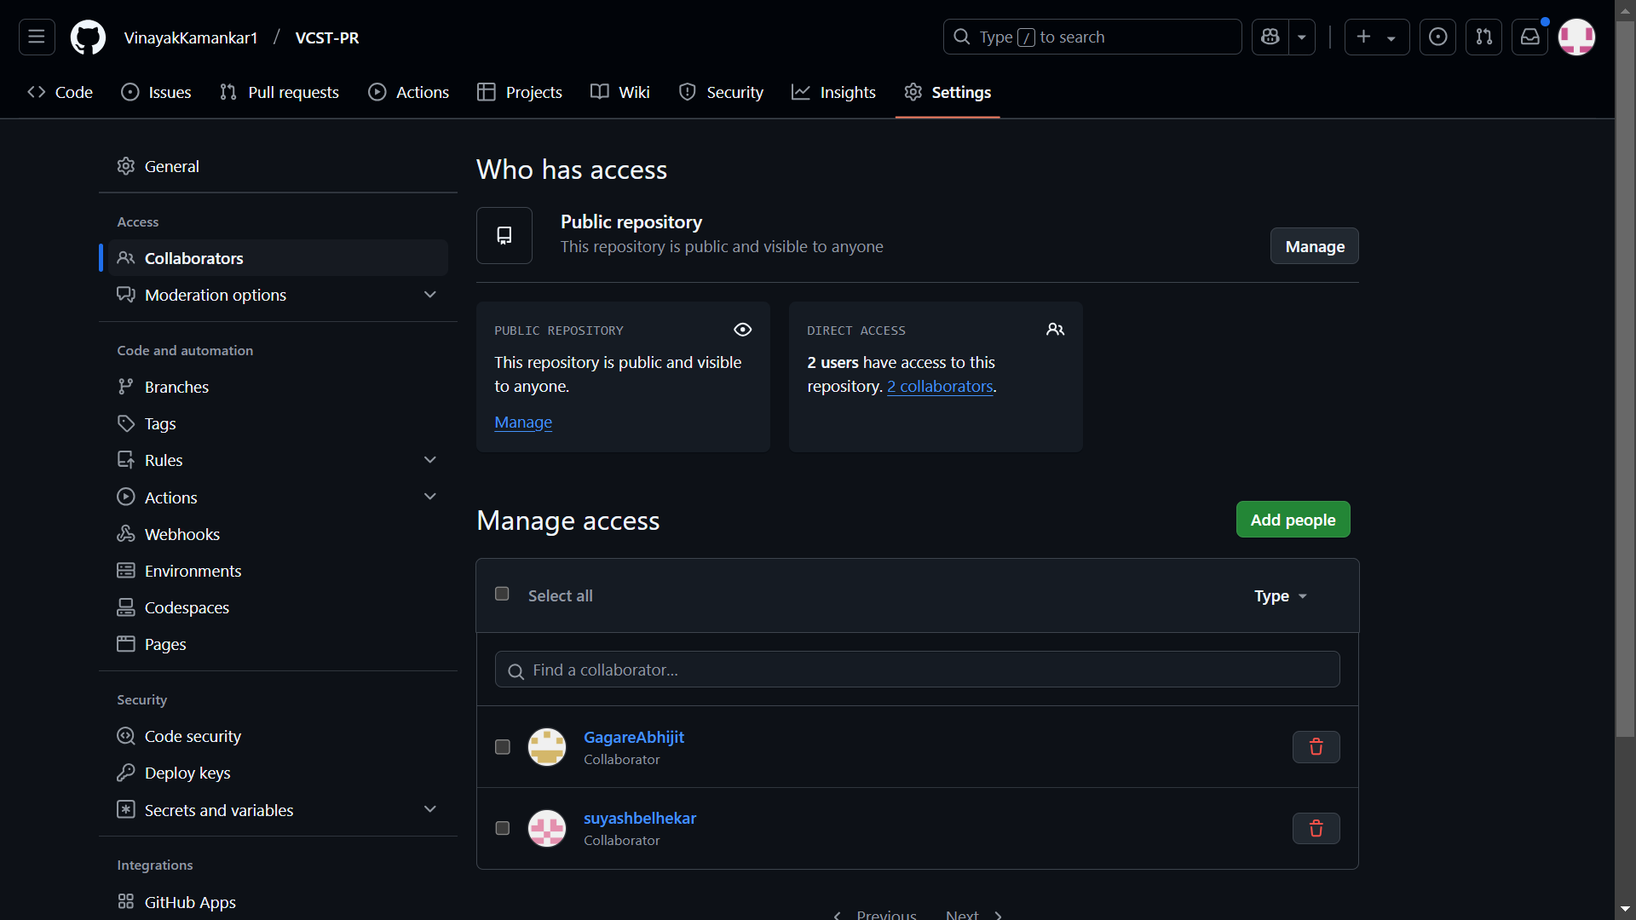

**6. Branch Creation**

A new branch is created to work on a specific feature .

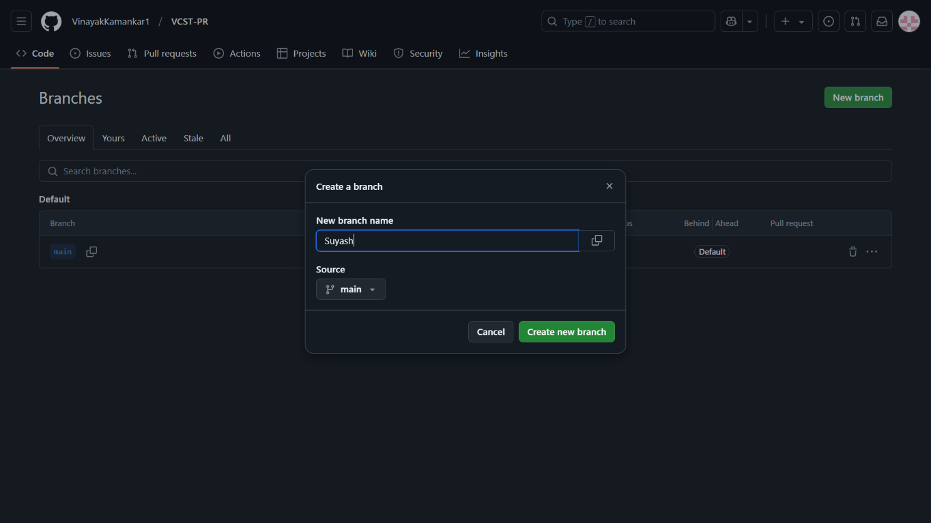

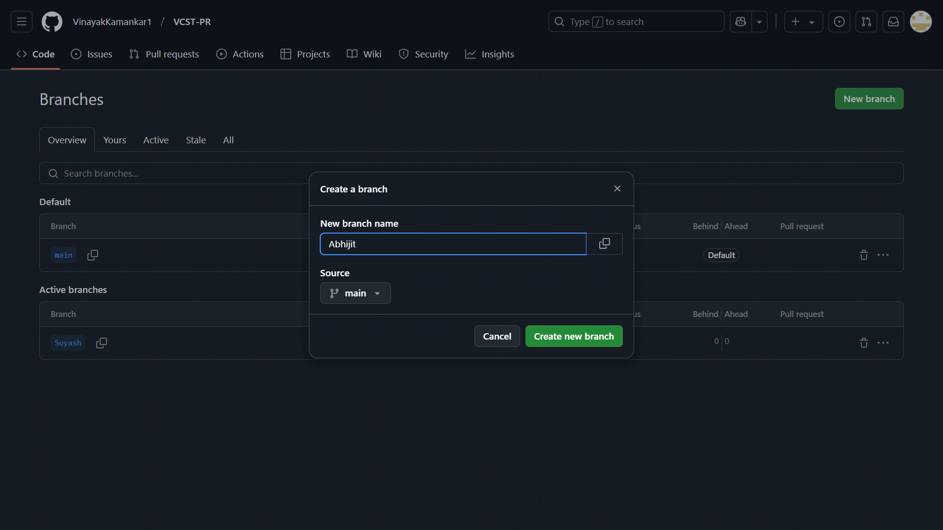

**7. File Push on On Main Branch**

A file is uploaded and committed directly to the main branch.

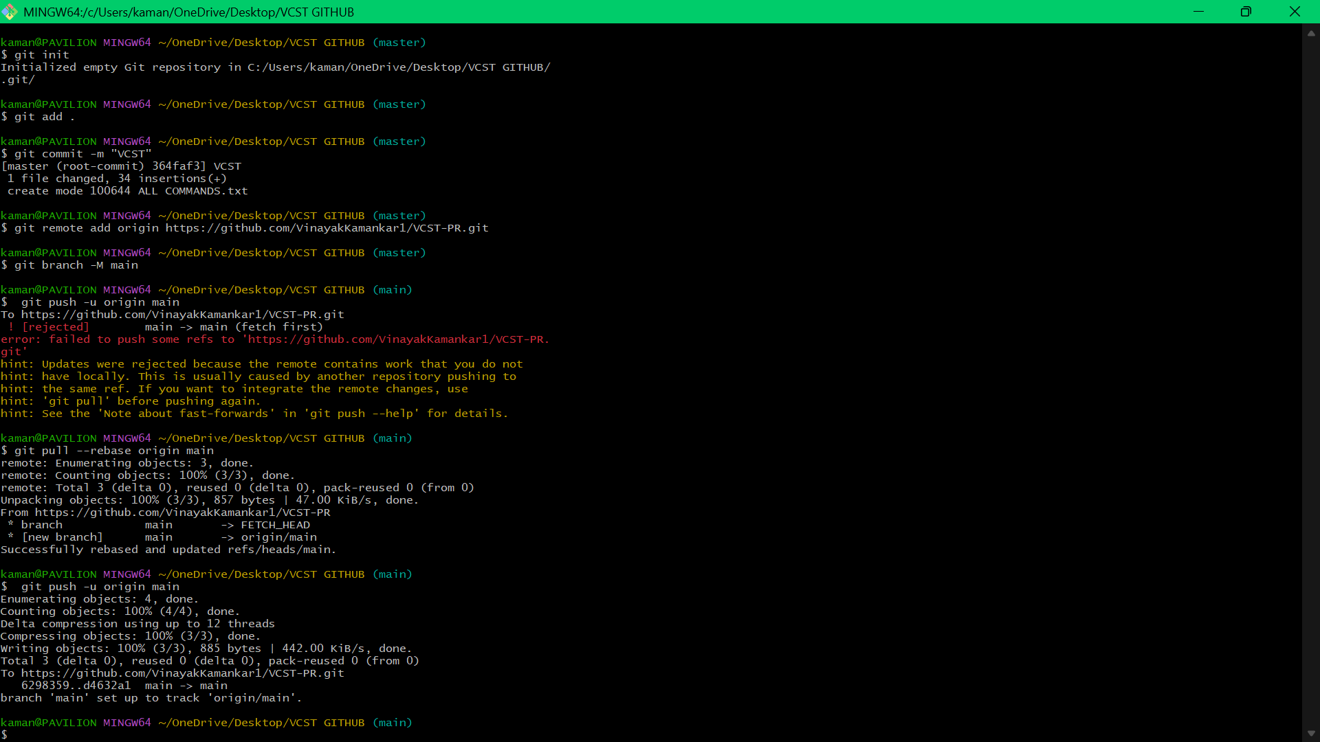

**8. File Push By Suyash**

Suyash successfully pushes a file to the repository.

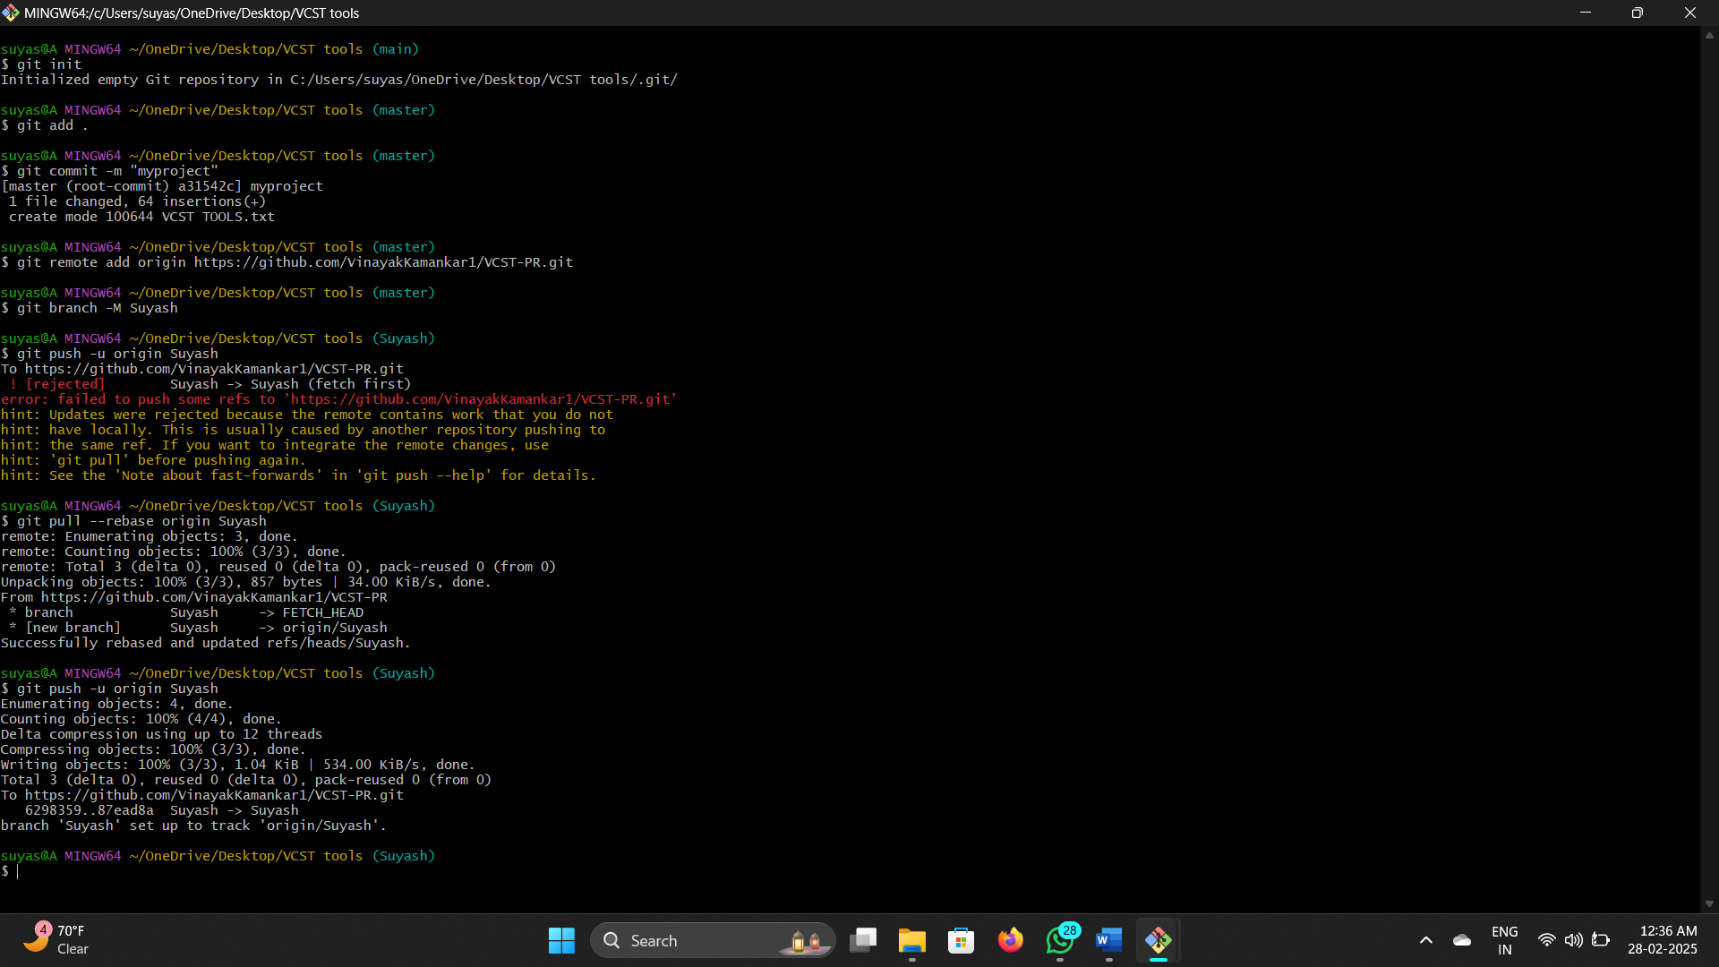

9. File Push By Abhijit

Abhijit successfully pushes a file to the repository.

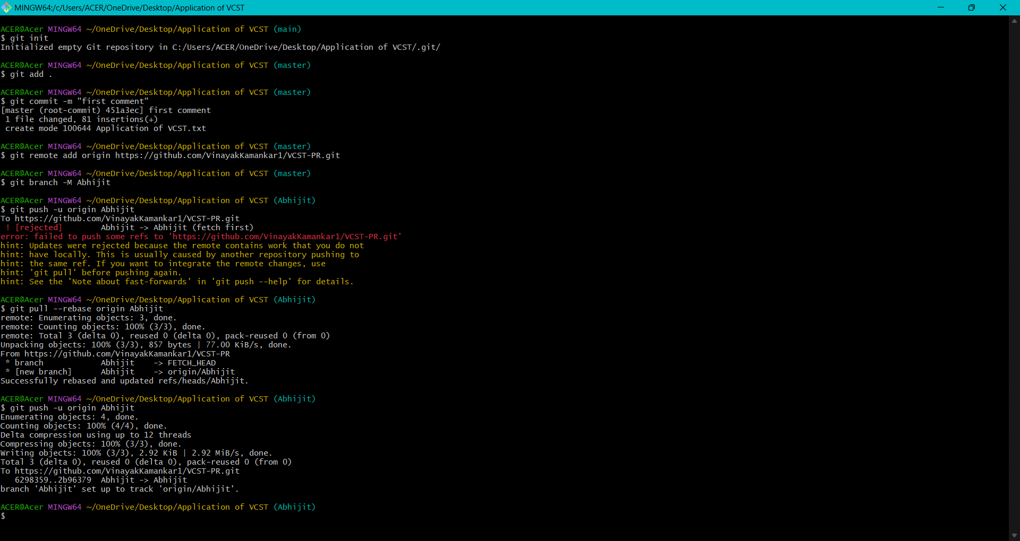

**10. File Push Succesfully**

The file is uploaded and committed without any issues.

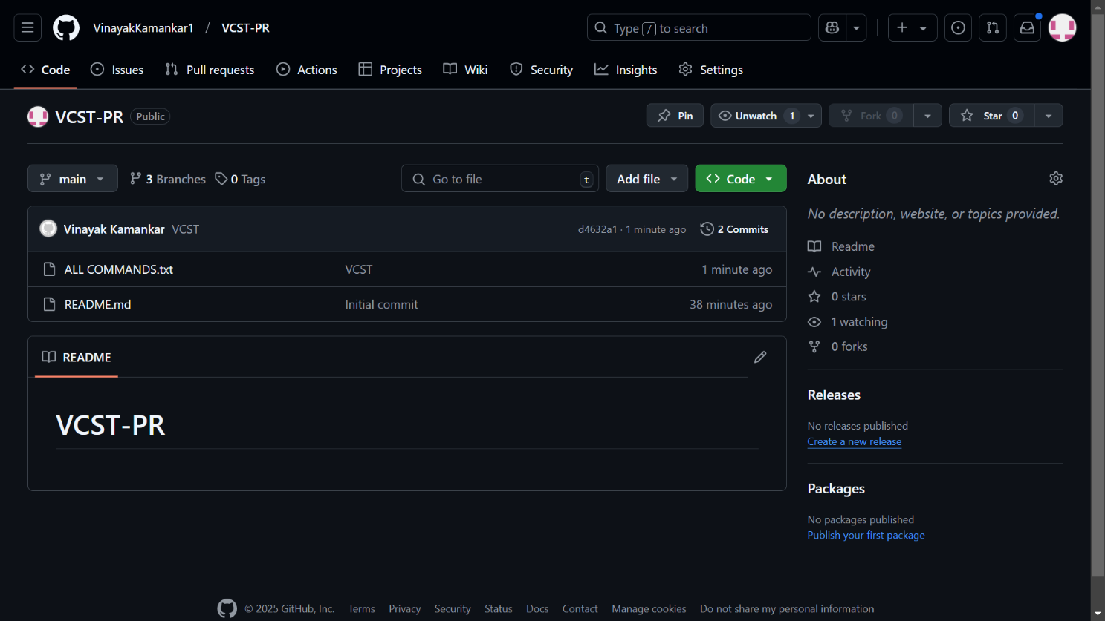

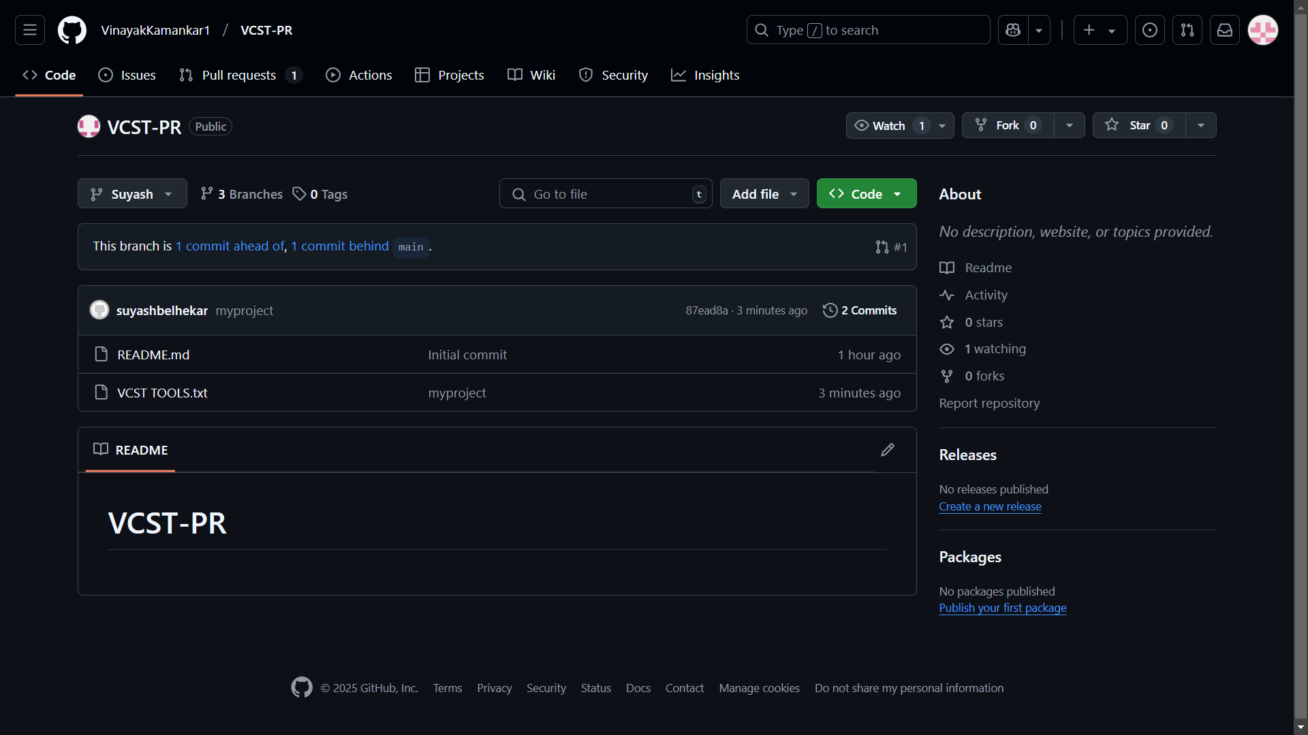

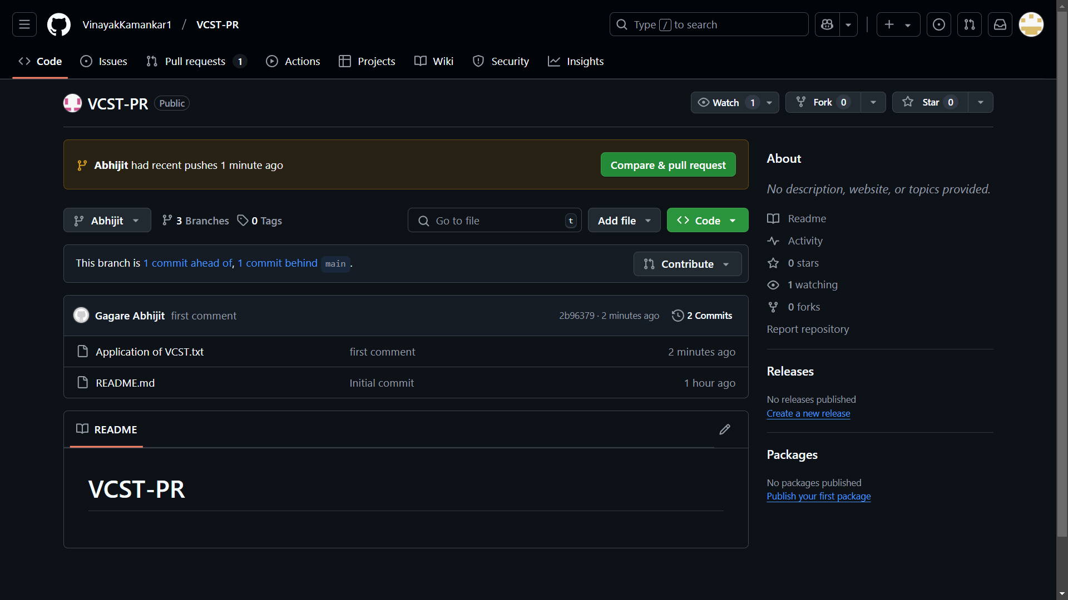

**11. Merge All Branches**

All branches are combined into the main branch to unify the code.

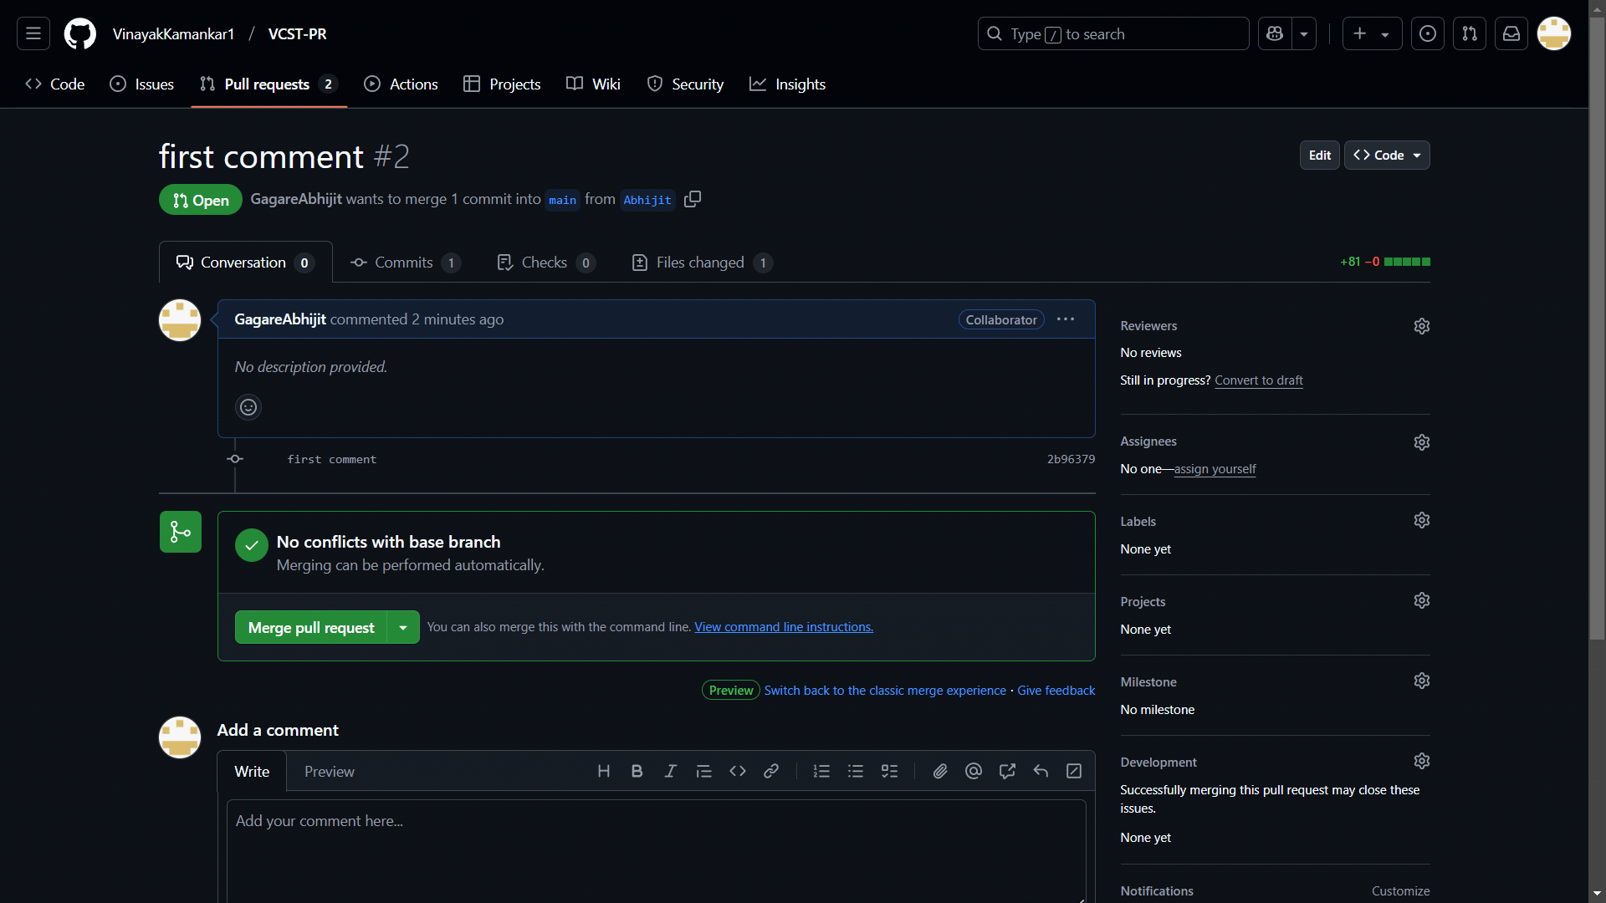

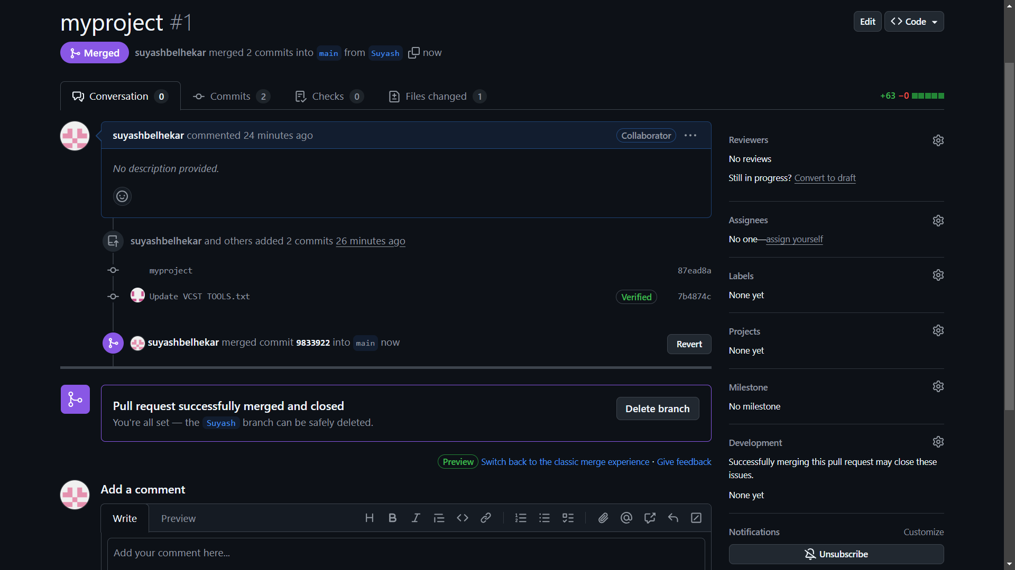

**12. Merge Succesfull**

The branches are merged successfully without conflicts

